**MINAHIL QADIR**

**BSAI-3A(047)**

**TASK 2:**

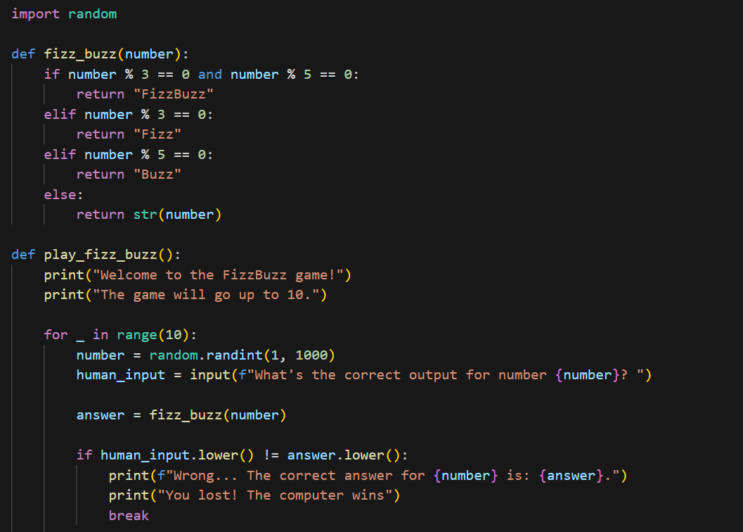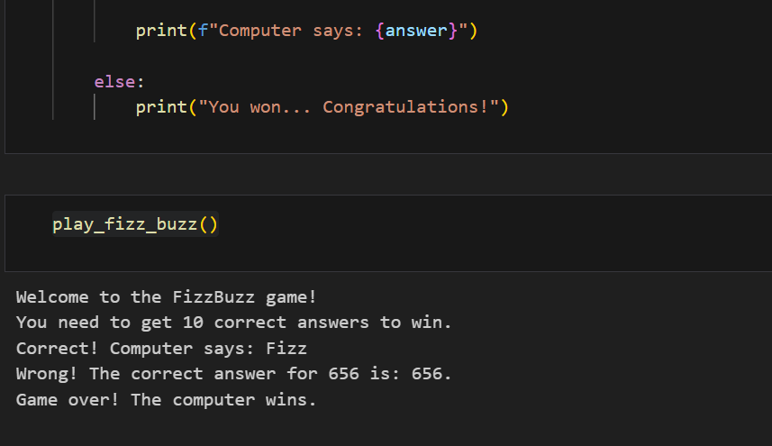

The game starts by displaying a welcome message and explaining the rules.

A loop runs 10 times, generating a random number (1-1000) in each round.

The player is asked to enter the correct FizzBuzz output based on the number.

The program checks the answer using the fizz_buzz function:

If divisible by 3 and 5, the correct answer is "FizzBuzz".

If only by 3, it's "Fizz".

If only by 5, it's "Buzz".

Otherwise, it's the number itself.

If the player’s answer is wrong, the game immediately ends, and the computer wins.

If the answer is correct, the computer prints the response and continues.

If the player gets 10 correct answers in a row, they win the game.

At any mistake, the game stops, and the player loses.

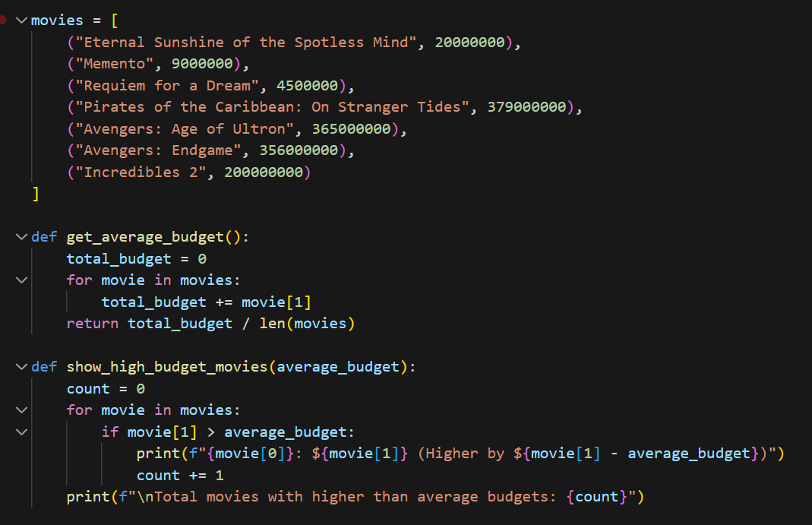

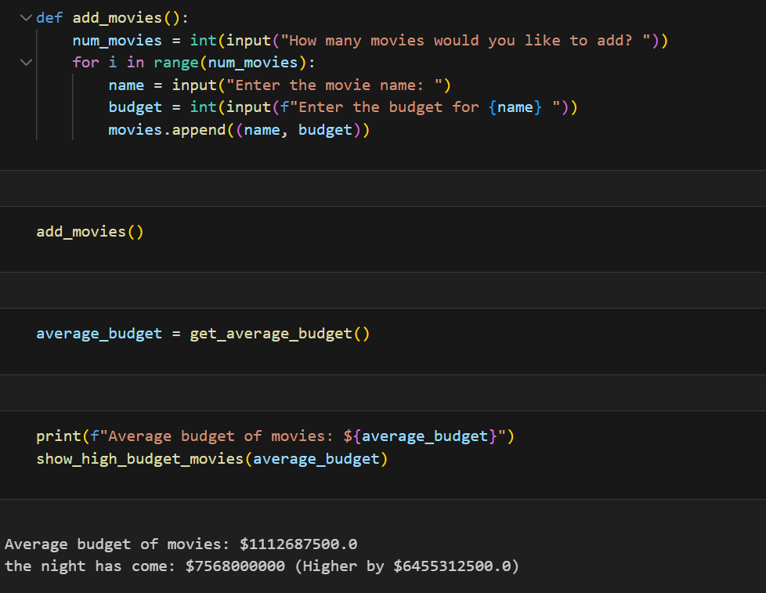



The program stores movies with their budgets in a list.

get_average_budget() calculates the average budget of all movies.

show_high_budget_movies(average_budget) prints movies with budgets above the average and their difference.

add_movies() allows the user to add new movies with their budgets.

The program adds movies, calculates the average budget, and displays movies exceeding the average budget.